CAS PY 106

Pre-lecture note 8

1. Capacitors
2. Capacitor is device for storing charges. Simple type of capacitors that is main focus is parallel-plate capacitor, two identical metal plates placed parallel to another, with plates separated by distance d
3. 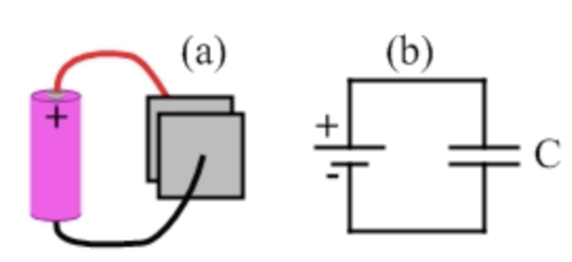
4. Figure a shows parallel-plate capacitor connected by two wires to battery
5. Figure b is same as figure a but represented as a circuit diagram. Capacitor on a circuit diagram is shown as two parallel lines of equal length, while battery is indicated by two parallel lines of unequal length
6. The battery’s role is to pump electrons from one plate to another, giving charge of +Q on one plate and –Q on the other, allowing capacitor to store a charge of Q
7. Parallel-plate Capacitor
8. Parallel-plate capacitor is pair of identical conducting plates, each of area A, placed parallel to one another and separated by distance d
9. With nothing between plates, capacitance is

C = e\*A/d

Where e = 8.85\*10^-12 (permittivity of free space)

Q = C \* V

1. 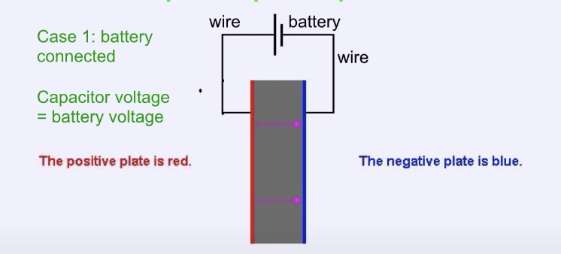
2. Initial value of capacitance is C. The battery voltage is V. The initial value of stored charge is Q. The initial electric field is EE. The initial value of energy stored is U
3. Case 1 – battery remains connected
4. Changing distance between plates 🡪 changes C, Q, U, and E (voltage doesn’t change)
5. Ex) reduce distance by ½ and add dielectric material with constant 2.5
6. V 🡪 original V
7. C 🡪 k \* e \* A / d = 2.5\*2 \* e \* A/ (½ d) = 5e\*A /d = 5C
8. Q 🡪 C \* V = 5C\*V = 5Q
9. U 🡪 ½ \* Q \* V = ½ \* 5Q \* V = 5U
10. E 🡪 V/d 🡪 V/ (½ \*d) = 2E
11. Change dielectric constant (add insulating material between plates) 🡪 changes C, Q, U (voltage and electric field doesn’t change)
12. Case 2- battery disconnected (open switch)
13. 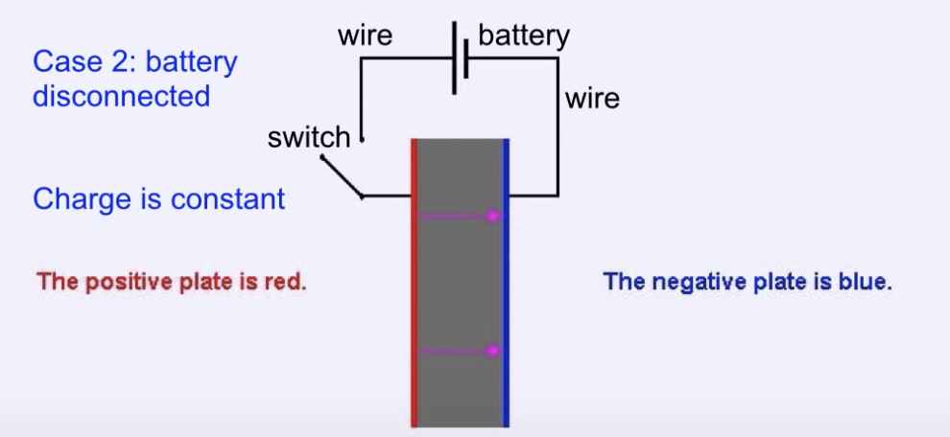
14. Changing distance between plates 🡪 changes C, U, and V (E and Q are not affected)
15. Changing dielectric constant 🡪 changes C, U, E, V (Q is not affected)
16. Ex) V=12, distance between plate is reduced by 2, battery disconnected, dielectric constant = 2.5
17. Q 🡪 C \* V = 2C \* V = 2Q (distance between plate is reduced by 2, C is increased be 2 at this stage)
18. C 🡪 k \* e \* A / d = 2.5\*2 \* e \* A/ (½ d) = 5e\*A /d = 5C
19. V 🡪 Q/C 🡪 2Q/5C = 0.4V 🡪 4.8V
20. E 🡪 V/d 🡪 0.4V/.5d = 0.8E
21. U = ½ \* Q \* V = ½ \* 2Q \* .4V = ½ \* .8QV = 0.8U
22. Electric field in a capacitor
23. With a parallel-plate capacitor, we use approximation that electric field between the capacitor plates is uniform
24. The field points from positive plate to negative plate. If potential difference across capacitor is V, distance between plates is d, the magnitude of electric field is

E = v/d

1. Energy in a capacitor
2. When we move a single charge q through potential difference V, its potential energy changes by q \* V
3. Charging capacitor involves moving large number of charges from one capacitor plate to another. If V is the final potential difference on capacitor, Q is the magnitude of the final charge on each plate, the energy stored in capacitor is

U = ½ \* Q \* V

½ exists because, on average, the charges were moved through potential difference of ½ V

1. Using Q = C \* V, energy stored in capacitor can be

U = ½ \* Q \* V = ½ \* C \* V^2 = Q^2 /2C

1. Dielectrics
2. When material is inserted into capacitor, we call material dielectric
3. Adding dielectric allows the capacitor to store more charge for a given potential difference
4. 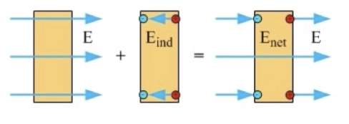
5. 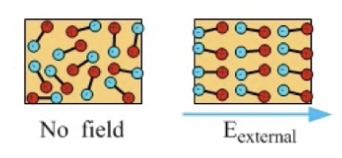
6. When dielectric inserted into charged capacitor, the dielectric is polarized by the field. The electric field from the dielectric will partially cancel the electric field from charge on capacitor plates.
7. If capacitor is connected to battery at the time, battery is able to store more charge on capacitor, bringing field back to its original value (get more charge)
8. Dielectric constant
9. Every material has dielectric constant k that tells you how effective the dielectric is at increasing the amount of charge stored.

K = E0 /Enet > 1

E0 is field without dielectric

Enet is field with dielectric

1. For parallel-plat capacitor containing a dielectric, capacitance is C = k\*e\*A/d
2. In general, adding dielectric to capacitor increases the capacitance by factor k
3. Two regimes
4. Two main ways we work with capacitors
5. Capacitor stays connected to battery. In this case, voltage is constant because it is battery voltage. Then, adjusting something about capacitor will affect the amount of charge stored in the capacitor
6. Capacitor is first charged by connected to battery and connection is removed. The charge on the capacitor is constant because there is no way for charge to flow from one plate to another. Adjusting something about capacitor affects potential difference across capacitor